**PROJECT 1**

**Implementing a Team Communication Solution Using Mattermost and AWS**

1. CREATING VPC

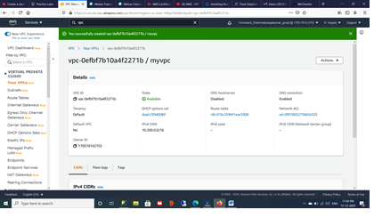

1. Creating private and public subnets

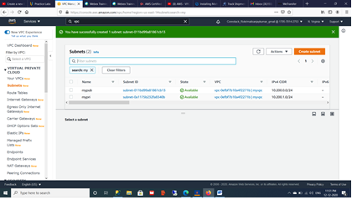

1. Creating route table for public and private subnet

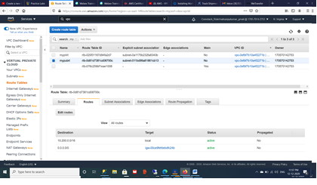

1. Creating Internet gateway

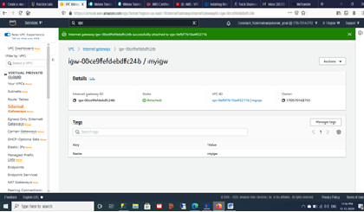

1. Create Nat gateway

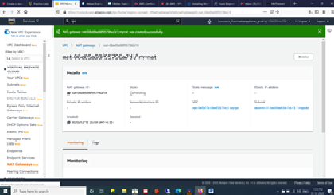

1. Create two ec2 instance of Ubuntu 18.4

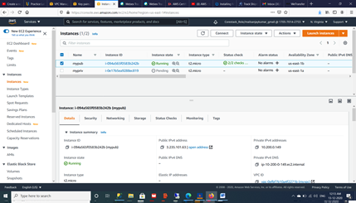

1. Connect to ec2 public instance

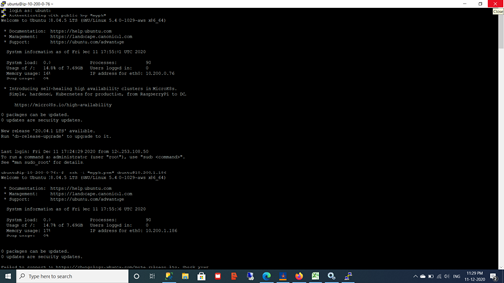

1. Install mysql to private instance

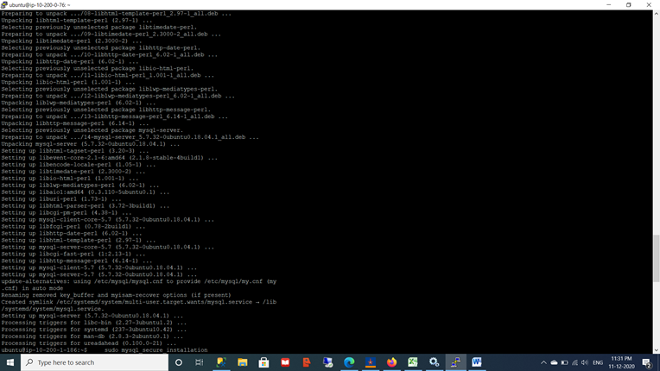

1. Mattermost installed on public instance

